**Section One : Title, Objective, Responsibilities**















* **Title :** IoT based blood pressure monitoring system.
* **Objective :** The purpose of this research is to provide a solution to this by using IoT, which is now found in the computer technology of the modern world, to prevent deaths due to nurse & doctor negligence in hospitals.
* **Research Question :** What do you want to find out this research?

**Section Two : Reason for choosing this research project**

If I chose this topic I am studying Computer science specialized in software engineering at BCAS Campus. The title published by Pearson in my academic year 2021 is IoT which is why I have chosen IoT as the research & project title based on the research & project I have to do this year.















**Section Three : Literature sources searched**

<https://www.sciencedirect.com/science/article/pii/S1877050917316745>

<https://ijssst.info/Vol-16/No-4/paper9.pdf>

<https://www.sciencedirect.com/science/article/pii/S1877050919306684>















**Section Four : Activities & Timescales**















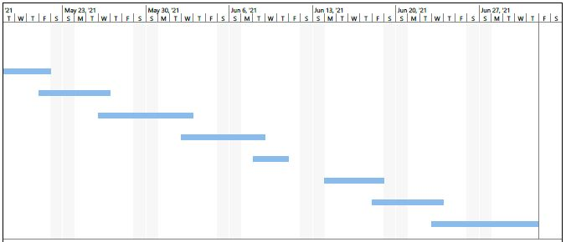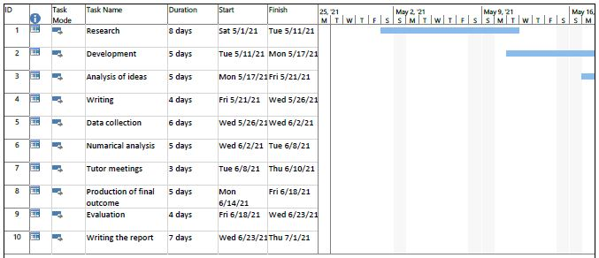

**Section Five : Research approach & Methodologies**

**Research approach :** This research employs deductive approach to select the most efficient algorithm by comparing the existing theories, algorithms and tools & technologies available.

**Methodologies :** This research requires the use of quantitative aspects are incorporated to reach the expected outcome. The psychological aspects are treated and analyzed by means of quantitative approach whereas machine learning involves quantitative approach such as statistical computation.

**Questionnaires :** Questionnaires were chosen for this research because they are a reliable and quick method to collect information from multiple respondents in an efficient and timely manner. This is especially important when it comes to large projects, with several complex objectives, where time is one of the major constraints. This study was no exception and questionnaires were a quick and effective way for the researcher to reach multiple respondents within several weeks. A general disadvantage of the questionnaires however is their fixed and strict format, which eliminates the possibility for more in-depth or abstract observation. Again, this study was not an exception from this rule, as the questionnaires provided linear and clear results, but many elements from the research were left uncovered.











